**DEPT.ECE 3-D RADAR MODEL USING ULTRASONIC SENSOR FOR TRAJECTORY TRACKING 2021-2022**

## THE NATIONAL INSTITUTE OF ENGINEERING

MYSURU-570008

**DEPARTMENT OF ELECTRONICS AND COMMUNICATIONENGINEERING**

**MINI PROJECT [EC0201] –VI Semester**

**Synopsis On**

3-D Radar Model using Ultrasonic Sensor for trajectory tracking

**Under the guidance of: Lavanya M S**

Assistant Professor, Dept. of ECE.

**Submitted By:**

Ashish S - 4NI19EC020

Pavan Kumar - 4NI19EC068 Parikshith C - 4NI19EC066 Kruthika D - 4NI19EC045

# ABSTRACT

An important aspect of particle trajectory modeling is the assessment of the uncertainty in the final particle position. Three-dimensional trajectory tracking using different axes from standard-range helps in improving accuracy as well as determining the angle and the velocity statistics for these models were derived from the covariance functions of differences between the particle and the plane. Comparison of predicted trajectories and drifter tracks demonstrate that these predictions are superior to assuming the drifters stay at their initial position. Vertical shear between the effective depth of long-range as height is fixed, by varying the speed and position and help with the trajectory equation of a body in motion we can determine its location, in reasonable agreement with 95% success rate.

# TABLE OF CONTENTS

|  |  |  |
| --- | --- | --- |
| **Sl. No.** | **TOPICS** | **PAGE NUMBER** |
| **1.** | **INTRODUCTION** | 4 |
| **2.** | **LITERATURE SURVEY** | 6 |
| **3.** | **BLOCK DIAGRAM** | 8 |
| **4.** | **METHODOLOGY** | 11 |
| **5.** | **RESULTS AND CONCLUSION** | 12 |
| **6.** | **APPLICATIONS** | 15 |
| **7.** | **LIMITATIONS** | 15 |
| **8.** | **FUTURE SCOPE** | 15 |
| **9.** | **REFERNCES** | 16 |

**INTRODUCTION**

In this project, we have designed Arduino RADAR Model using Ultrasonic Sensor for Detection & Ranging. RADAR is an object detection system that uses radio waves to identify the range, altitude, direction, and speed of the objects. The radar antenna transmits radio wave pulses that bounce off any object in its path. The object returns a portion of the wave received by the receiver which is in line of sight with the transmitter.

This Arduino RADAR project aims to achieve a radar system prototype based on an Arduino board, capable of

detecting stationary and moving objects.

The sensors present are:

1. Distance Measurement Using Arduino & HC-SR04 Ultrasonic Sensor
2. Arduino Ultrasonic Range Finder with HC-SR04 on OLED Display Image

Objectives of the Research The research study on RADAR was conducted for several reasons. The following are some of the objectives attributed to the project:

1. To enable the understanding of how radars works and their concepts
2. To understand the terminologies and equations used in Radar Systems
3. To know how to apply formulas and equations to solve problems attributed to radar systems
4. To identify the Problems and challenges affecting the performance of radar systems

The time needed for echo to return can be converted to the required distance between the person and object. The principle behind the reflected echo is similar to that of a radar system (Chapman & Hall, 2000).. The system also uses the electromagnetic energy pulses similar to a person shouting in the direction of a sound reflecting object. A very small percentage of the energy undergoes the reflection process before returning to the radar system. The returned energy is called echo. In this case, a radar system utilizes the echo in determining the direction and distance of the reflecting object.

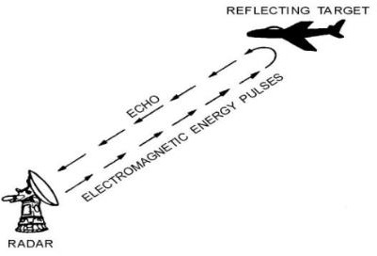

**Figure 1: Radar**

# LITERATURE SURVEY

Objectives of the Research The research study on RADAR was conducted for several reasons. The following are some of the objectives attributed to the project:

1. To enable the understanding of how radars works and their concepts
2. To understand the terminologies and equations used in Radar Systems
3. To know how to apply formulas and equations to solve problems attributed to radar systems
4. To identify the Problems and challenges affecting the performance of radar systems
5. Literature Review

Technology attributed to the radar from that time has been improving. For instance, the modern radar systems are smaller, better, and more efficient than the previous devices. A radar system operates on the electronic principle similar to that of sound-wave reflection. A person shouting in the direction of a sound reflecting object will hear an echo. The knowledge of the speed of the sound in the air would assist in the estimation of the distance and direction of the reflecting object.

The time needed for echo to return can be converted to the required distance between the person and object. The principle behind the reflected echo is similar to that of a radar system (Chapman & Hall, 2000).. The system also uses the electromagnetic energy pulses similar to a person shouting in the direction of a sound reflecting object. A very small percentage of the energy undergoes the reflection process before returning to the radar system. The returned energy is called echo. In this case, a radar system utilizes the echo in determining the direction and distance of the reflecting object.

Based on the following papers we formulated a comparison:

* + Ali Adaptive target tracking algorithms for airborne ultrasonic rangefinders, Author(s): A.M. Sabatini 1
  + Minimally privacy ultrasonic radar embedded on ceiling Y. Nishida;

T. Hori; S. Murakami; H. MizoguchiVijay Kumar Meena.

* + M. V. Paulet, A. Salceanu and O. M. Neacsu, "Ultrasonic radar," 2016 International Conference and Exposition on Electrical and Power Engineering (EPE), 2016, pp. 551-554, doi: 10.1109/ICEPE.2016.7781400.
  + Tedeschi, S. Calcaterra and F. Benedetto, "Ultrasonic RAdar System (URAS): Arduino and Virtual Reality for a Light-Free Mapping of Indoor Environments," in IEEE Sensors Journal, vol. 17, no. 14, pp. 4595-4604, 15 July15, 2017, doi: 10.1109/JSEN.2017.2708840.

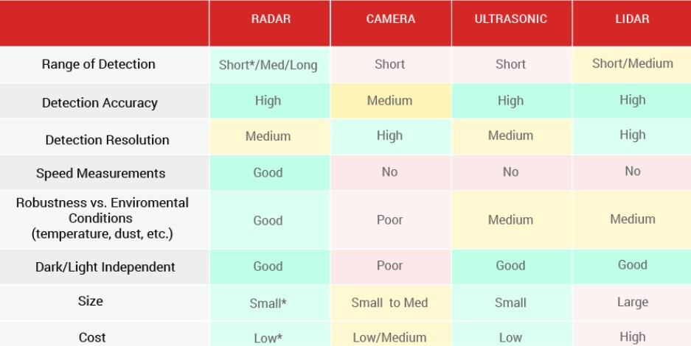

**Figure 2: Pugh Matrix**

According to our survey we chose this project based on current technologies, relevance to our syllabus and industrial application

# BLOCK DIAGRAM

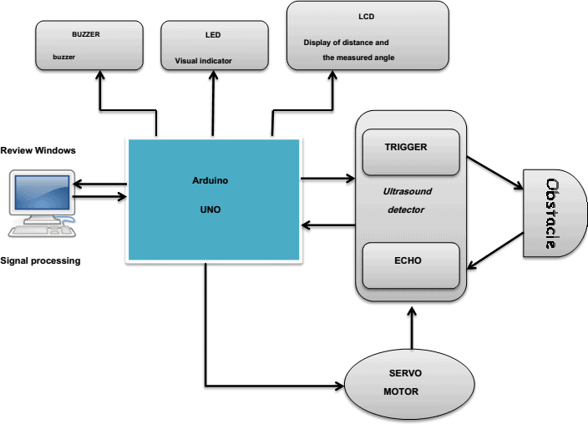

**Figure 3: Block Diagram**

Arduino board sends a signal of +5V to the trig pin of Ultrasonic Sensor HC-SR04 which triggers the sensor. Then it provides rotational action at the servo motor mechanically fitted along with ultrasonic Sensor HC-SR04 so that it can detect the moving objects and locate within 180 degrees.

It has two main components: the transmitter & receiver. The transmitter emits the sound using a piezoelectric crystal, and the receiver encounters the sound after it has travelled to and from the target.

For the calculation of the object distance, the sensor measures the time taken by the signal to travel between the transmission of the sound by the transmitter to the reflecting back towards the receiver.

The formula for this calculation is, D = ½ T x C

Where,

D = distance, T = time

C = speed of sound which is 343 meters/second.

Hardware system consist of basically 3 components named as Arduino, servo-motor, and ultra-sonic sensor. Ultrasonic sensor is mounded upon a servo motor which helps it to move and provide it a turning mechanism. Both ultrasonic sensor and servo motor are controlled and powered by Arduino.

> control line of servo motor is connected to D6 pin of Arduino

>connect echo pin of ultrasonic sensor to D8 pin of Arduino

>D7 pin of Arduino is connected to Trig pin of sensor

>VCC pins of servo motor and ultrasonic sensor is connected to 5V pin ofArduino

>ground pin of Arduino is connected to ground pin of both servo motor and ultra- sonic sensor.

>Transmitter pin of arduino to receiver pin of bolt and viceversa.

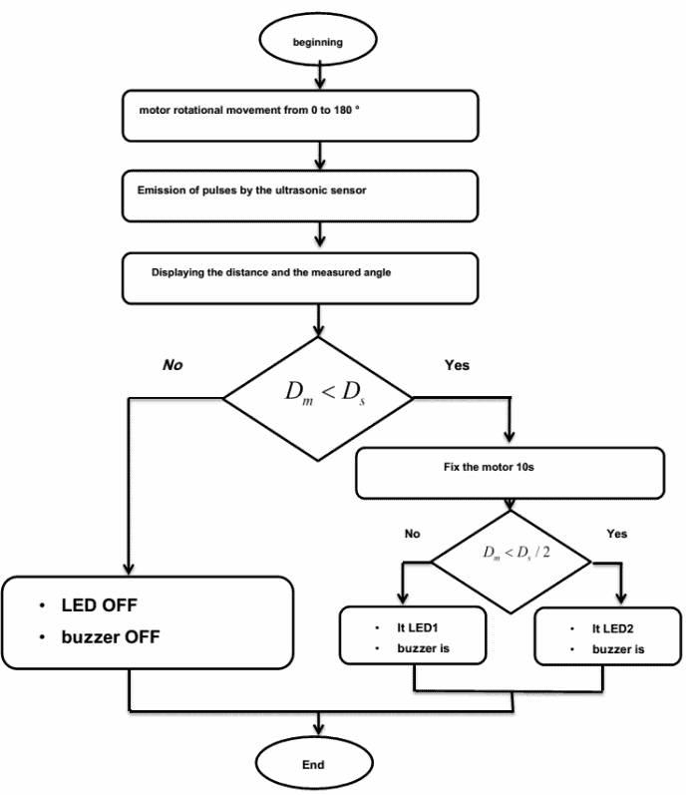

**Figure 4: Flowchart**

The Arduino sends a HIGH pulse width of (10 S) on the TRIGGER pin of the sensor to regenerate a series of

ultrasonic waves that propagate through the air until it touches an obstacle and returns in the opposite direction towards the sensor pin ECHO. The sensor detects the width of the pulse to calculate the distance.

The signal on pin ECHO the sensor remains at the HIGH position during transmission, thereby measuring the duration of the round trip of ultrasound and thus determine the distance.

The LCD display displays the calculated distance and the angle of rotation. The buzzer is an additional component, it rings when there is a detection (Tone1 and Tone2) along with LEDs. Both LEDs along with the buzzer determine the field where the object is located (near or distant).

**Eq 1: Trajectory equation**

where r = (x, y) denotes the position of the particle and u = (u, v) is the Eulerian velocity at position r and time t. The velocity can be decomposed into a large-scale, slowly varying component U, and a component ut representing sub grid-scale deviations which will be referred to as turbulence:

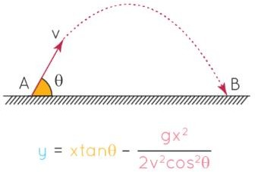

**Figure 5: Trajectory**

Methodology

* The process starts when the sensors detect an object:
* When it senses the servo motor moves the sensors in 45-degree arcs.
* Using the trajectory equation, it will analyze the location.
* Finally with the help of a guided UI, it will map the points of the trajectory

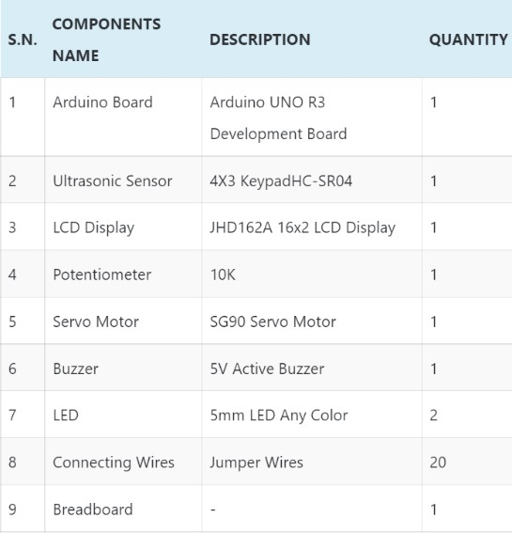

Table 1: Components

# RESULTS AND CONCLUSIONS

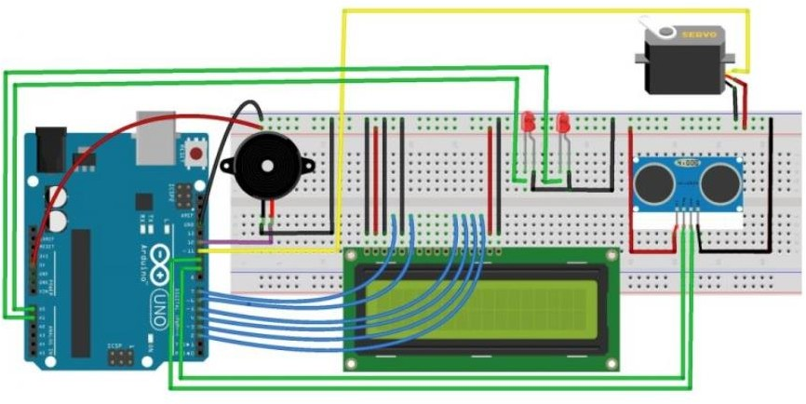

**Figure 6: Simulation**

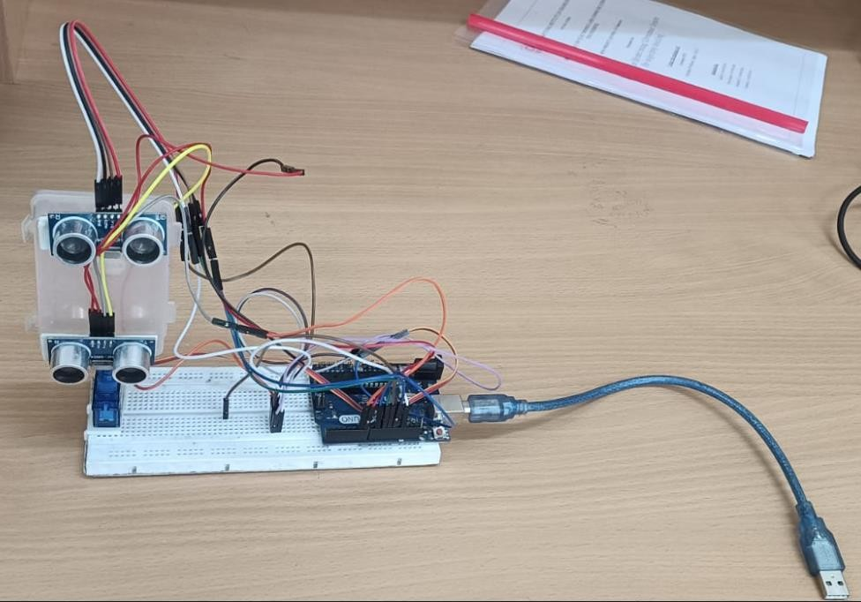

**Figure 8: Setup**

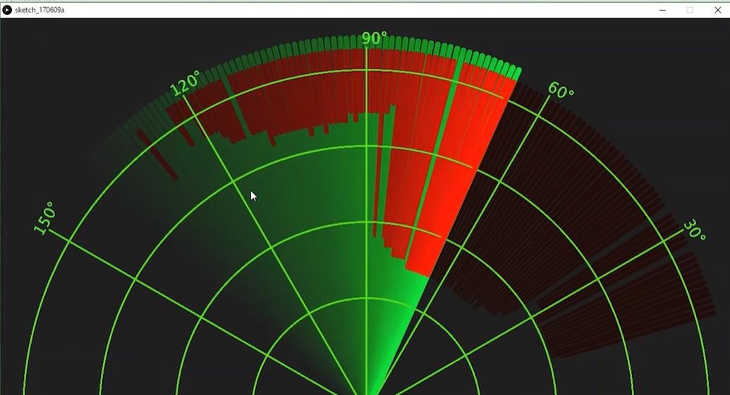

**Figure 9: Output**

* By addition of axes projectiles are tracked.
* Vertical shear between the effective depth of long-range as height is fixed, by varying the speed and position and help with the trajectory equation of a body in motion we can determine its location, in reasonable agreement with 95% success.

## Codes

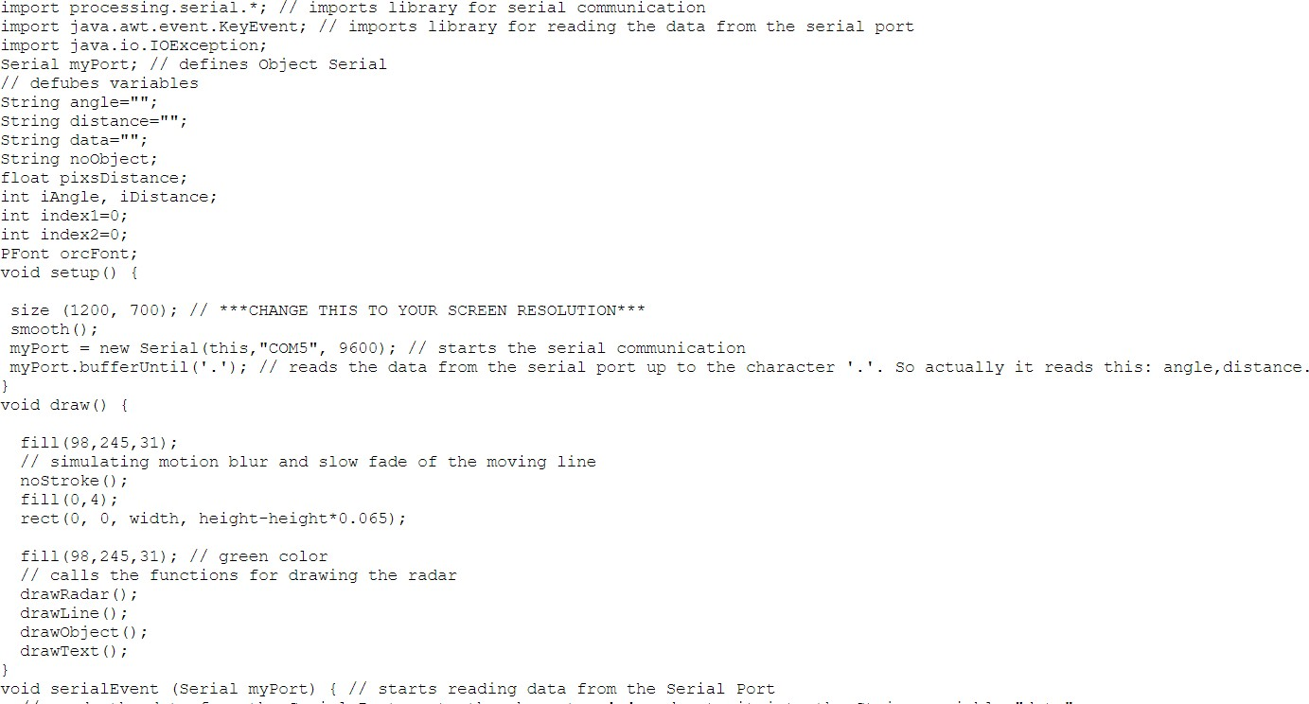

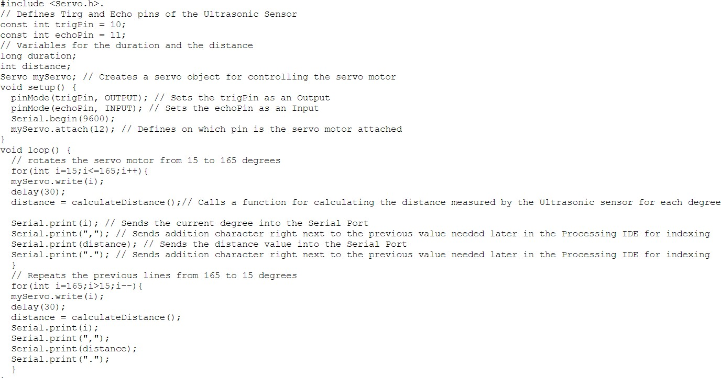

**Figure 10: Code for radar and UI**

# APPLICATIONS

* + Target detection
  + Missile tracking
  + Obstacle avoidance
  + Range of the target
  + Finding elevation and azimuth angles
  + Finding Doppler frequency shift

# LIMITATIONS

* + Accuracy is achieved only when multiple data lines are fed and tested
  + Inaccuracy with multiple objects

# FUTURE SCOPE

1. Multi Missile tracking
2. Satellite based imaging ranges from planetary exploration
3. IoT synchronization

# REFERENCES

* + M. V. Paulet, A. Salceanu and O. M. Neacsu, "Ultrasonic radar," 2016 International Conference and Exposition on Electrical and Power Engineering (EPE), 2016, pp. 551-554, doi: 10.1109/ICEPE.2016.7781400.
  + [www.ellenmacarthurfoundation.org](http://www.ellenmacarthurfoundation.org/)
  + Wikipedia
  + [www.researchgate.net](http://www.researchgate.net/)